Infosys Springboard Virtual Internship 6.0 Completion Report

Team Details
Batch Number: 4
Start date: 13-oct-2025
Names: BODDU HARIPRIYA
Internship Duration: 8 Weeks

1. Project Title

NeuroFleetX AI-Driven Urban Mobility Optimization System

2. Project Objective

The objective of this project is to design and develop a full-stack fleet management platform that ensures secure user authentication, smooth coordination between system roles, and efficient handling of fleet operations. Through Spring Boot, React, and MySQL integration, the system aims to improve operational transparency, automate core processes, and deliver a user-friendly interface for Admins, Managers, Drivers, and Customers.

3. Project description in detail

NeuroFleetX – AI-Driven Urban Mobility Optimization System
It provides real-time vehicle tracking, predictive maintenance, and automated route optimization. The system serves four user roles—Admin, Driver, Customer, and Passenger—with tailored interfaces and permissions. Built with React/TypeScript and Spring Boot, it features core modules for fleet operations, bookings, AI analytics, and emergency response. The platform uses real-time telemetry and machine learning to enhance safety, reduce costs, and improve operational efficiency across the entire vehicle lifecycle.
Admin
- Full system control: manages vehicles, users, bookings, and platform configuration.
- Monitors AI analytics dashboards, fleet performance KPIs, and financial reports.
- Oversees emergency response and approves major maintenance or system changes.

Driver
- Views assigned trips, real-time navigation, and vehicle telemetry via a dedicated interface.
- Updates trip statuses, logs driving hours, and reports incidents or maintenance needs.
- Receives AI-optimized routes and safety alerts based on real-time conditions.
Customer
- Books vehicles by specifying pickup/destination, time, and vehicle preferences.
- Tracks active rides in real-time on a map and views trip history with receipts.
- Manages payments, schedules recurring bookings, and accesses customer support.
Manager
- Tracks their assigned ride in real-time with ETA updates and driver details.
- Shares trip status with contacts and submit ratings/feedback post-completion.
- Receives safety notifications and can trigger emergency alerts if needed.

4. Timeline Overview
Week | Activities Planned | Activities Completed
Week 1 | - Project setup and planning.  - Set up the development environment and tools.  - Create the initial project structure for both frontend and backend. | Yes,  Completed as per plan
Week 2 | - Design and create the database schema (all tables) in MySQL.  - Set up the Spring Boot backend with basic configurations and JWT authentication.  - Set up the React frontend with Vite, TypeScript, and Tailwind CSS. | Yes,  Completed as per plan
Week 3 | - Develop the user authentication (login, register, token management) in the backend and frontend.  - Develop the user management module (admin can manage users) in the backend and frontend. | Yes,  Completed as per plan
Week 4 | - Develop the vehicle management module (CRUD) in the backend and frontend.  - Develop the telemetry data ingestion API and set up WebSocket for real-time updates. | Yes,  Completed as per plan
Week 5 | - Develop the booking system module (backend and frontend).  - Start working on the AI Control Center: implement the route optimization algorithm (backend). | Yes,  Completed as per plan
Week 6 | - Develop the Emergency Management module (backend and frontend).  - Develop the Maintenance module (backend and frontend). | Yes,  Completed as per plan
Week 7 | - Develop the System Health module (backend and frontend).  - Integrate all modules and perform initial integration testing. | Yes,  Completed as per plan
Week 8 | - Conduct comprehensive testing (including performance and security).  - Fix any issues and optimize the application.  - Prepare for deployment and deploy the application. | Yes,  Completed as per plan

5a. Key Milestones
Milestone | Description | Date Achieved
Project Kickoff | We have created the login and sign-up pages with basic authentication.  We have implemented role-based access control for four user roles: Admin, Driver, Customer, and Passenger. | 17-oct-2025
Prototype/First Draft | We have completed the registration and login functionality with JWT authentication.  We have established role management and permissions for different user types. | 24-oct-2035
Mid-Term Review | We have enhanced the fleet management module with real-time vehicle telemetry, including GPS tracking and vehicle status monitoring.  We have developed the AI route optimization module, providing smart route recommendations based on traffic and other factors. | 21-NOV-2025
Final Submission | Advanced customer booking features with smart recommendations and predictive pricing were added. Complete admin dashboard with comprehensive chart boards for fleet analytics, maintenance scheduling, and financial reporting was developed. | 5-NOV-2025
Presentation | We'll start by showing how users sign up and log in, and how the system knows if you're an admin, driver, or customer.  Next, we'll switch to the admin view to show the main dashboard, the city-wide activity maps, and all the charts that track fleet performance.  We'll finish by running a live demo of the whole system, showing how all the parts work together in our AI-powered fleet management platform. | 9-DEC-2025

5b. Project execution details
- Set up project on GitHub with main and develop branches for code management.
- Built the frontend using React with TypeScript, styled with Tailwind CSS.
- Created the backend with Spring Boot and secured it with JWT authentication.
- Designed and set up MySQL database tables for all system data.
- Made login/register pages and secured them with role-based access control.
- Built vehicle management pages to add, edit, and track fleet cars.
- Added live maps showing real-time vehicle locations using WebSockets.
- Created booking system where customers can schedule rides and see routes.
- Built admin dashboard with charts showing fleet analytics and city heatmaps.
- Added AI features for route optimization and vehicle recommendations.
- Implemented emergency panic button that alerts admins instantly.
- Tested everything with Postman and real users to fix bugs.
- Packed the app into Docker containers for easy deployment.
- Deployed frontend to Vercel and backend to AWS cloud servers.
- Prepared user guides and final documentation for all roles.
Setup Steps
- Clone the project: git clone https://github.com/your-username/neurofleetx.git
- Backend setup:
  - Navigate to backend folder: cd backend
  - Update database credentials in application.properties
  - Run: mvn spring-boot:run
- Frontend setup:
  - Open new terminal in frontend folder: cd frontend
  - Install packages: npm install
  - Run: npm run dev
- Database setup:
  - Import database.sql to MySQL
  - Run seeds for sample data

6. Snapshots / Screenshots
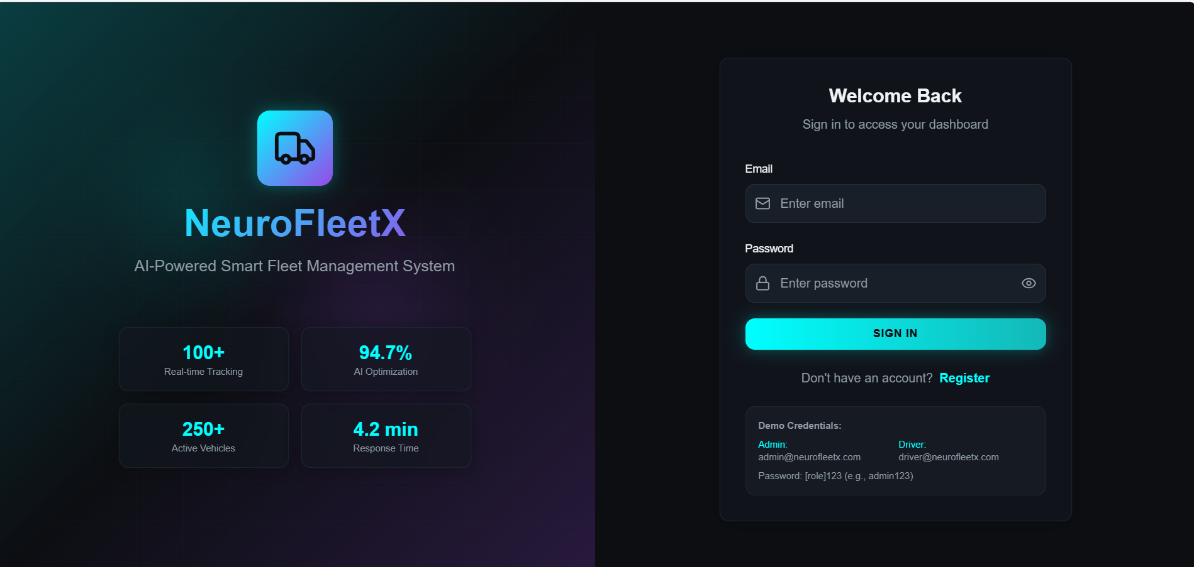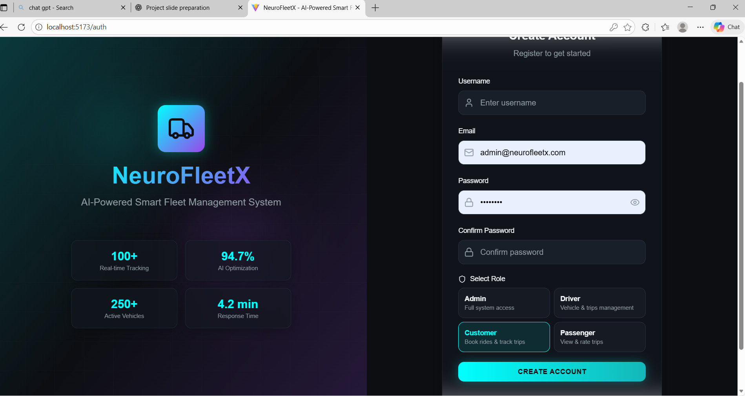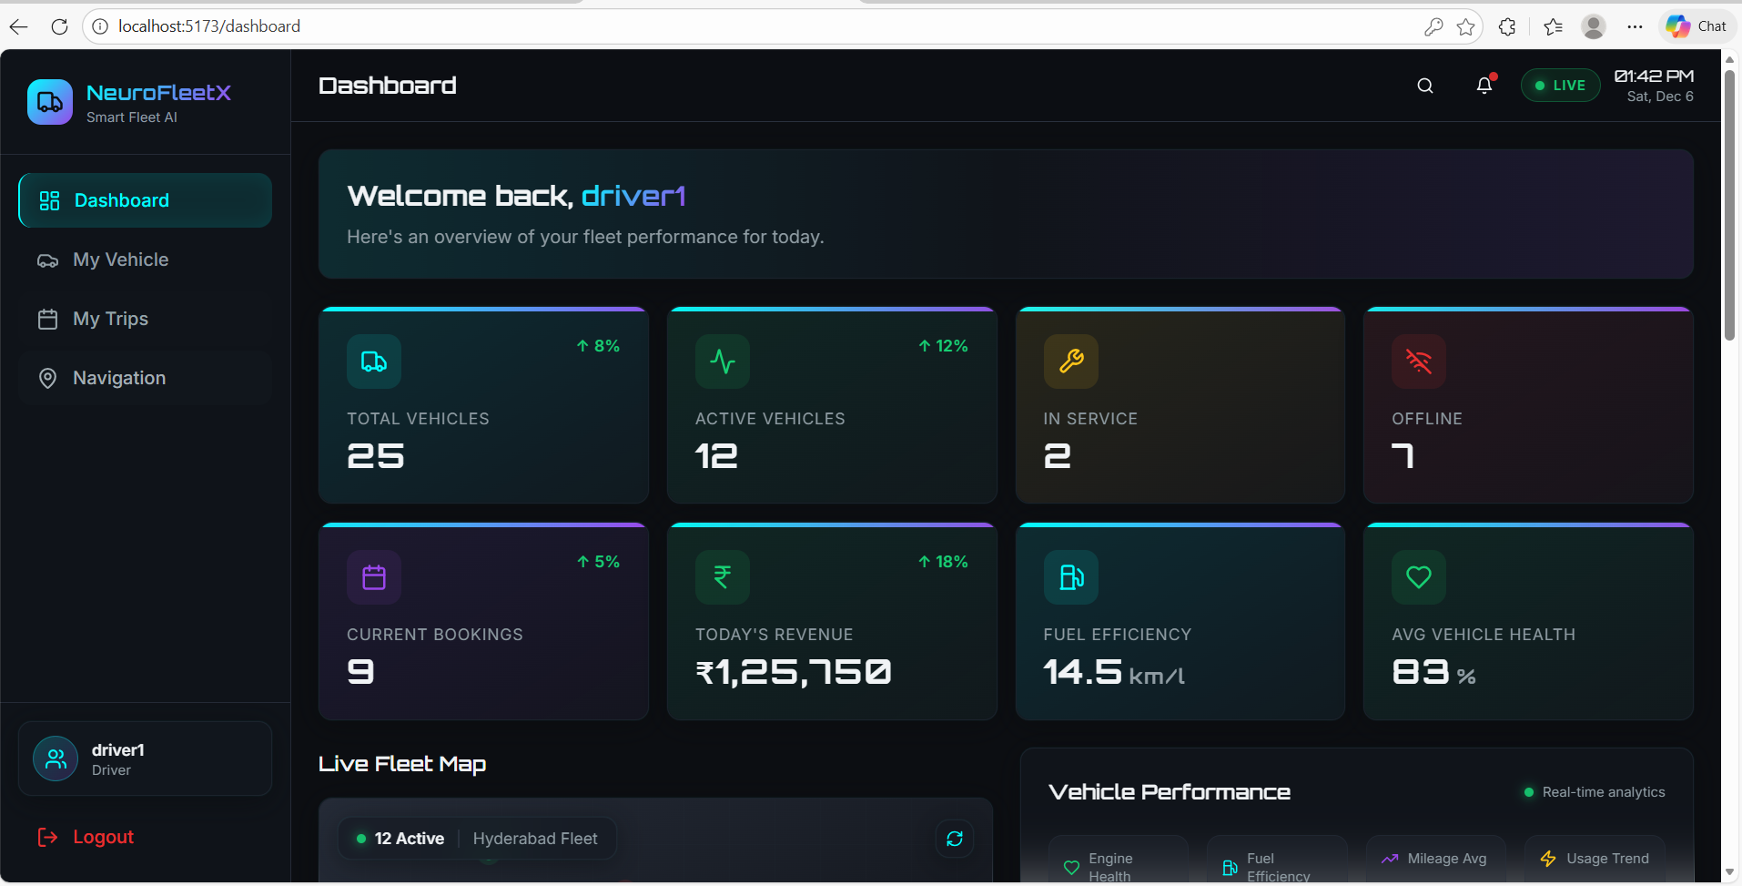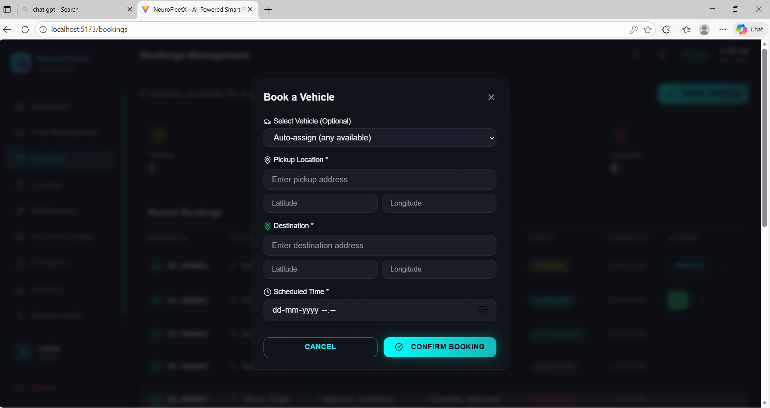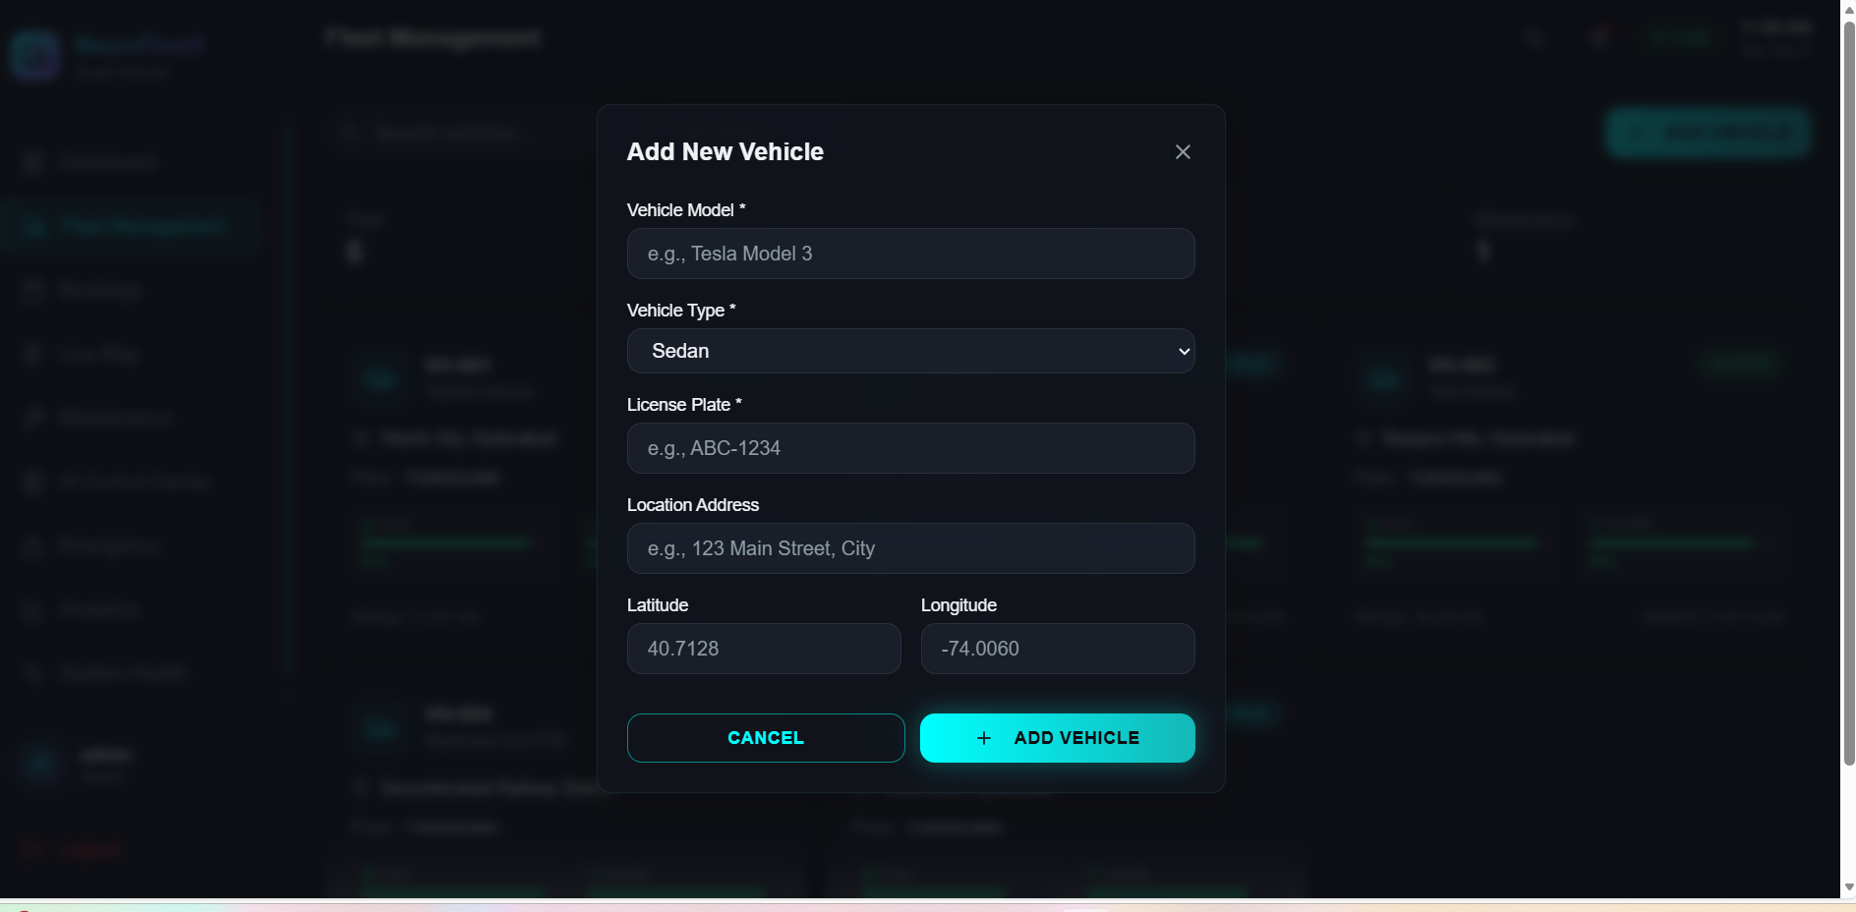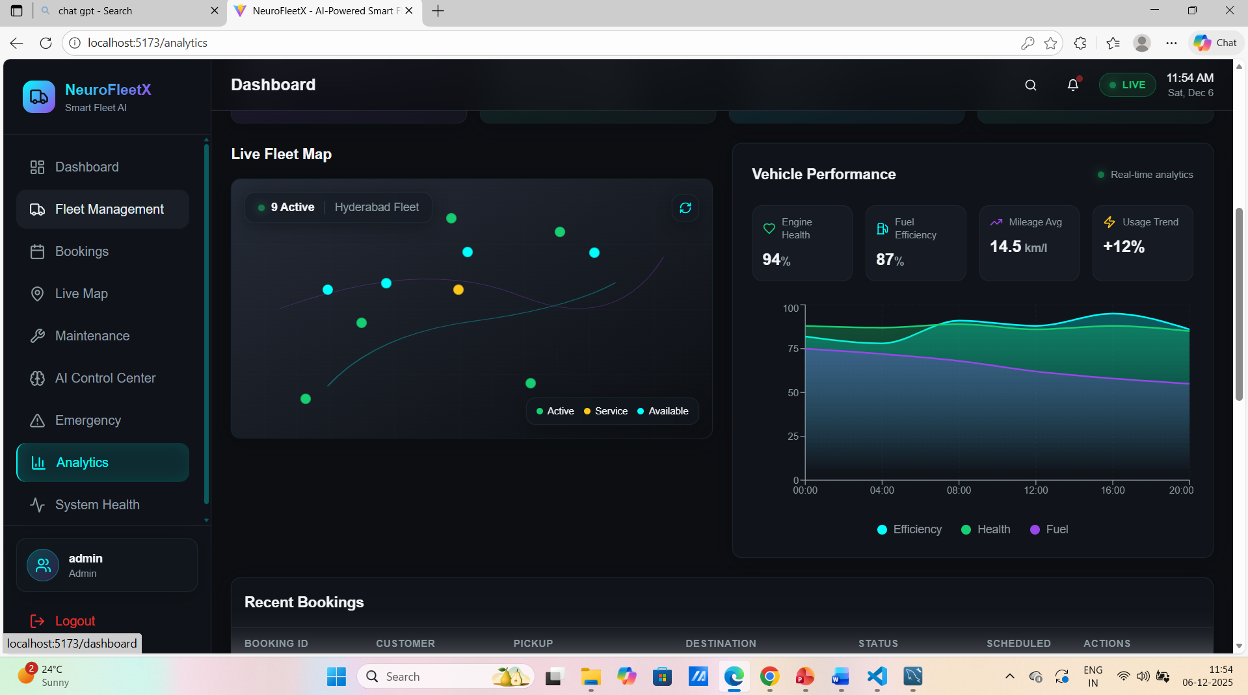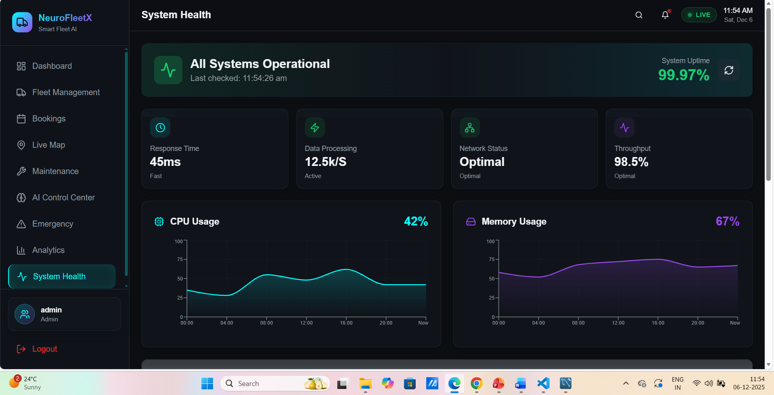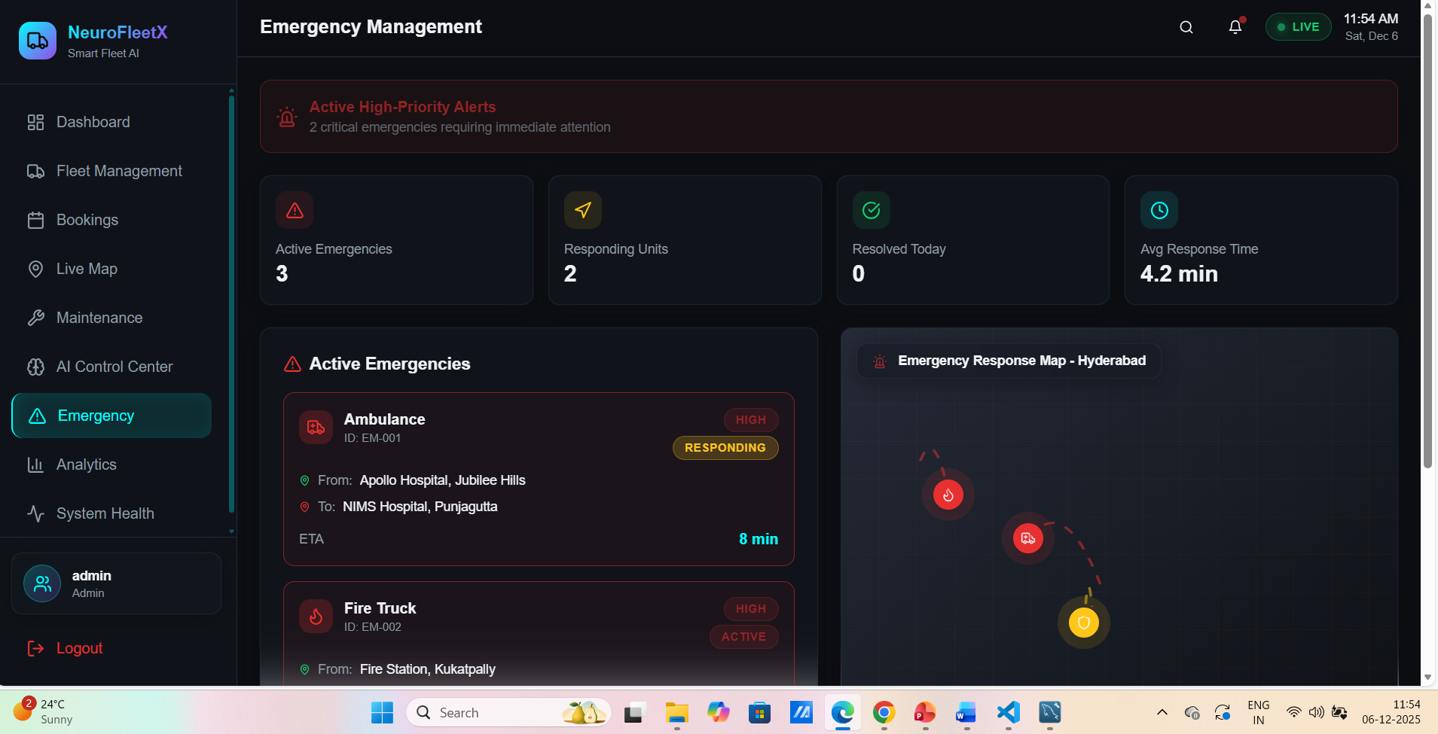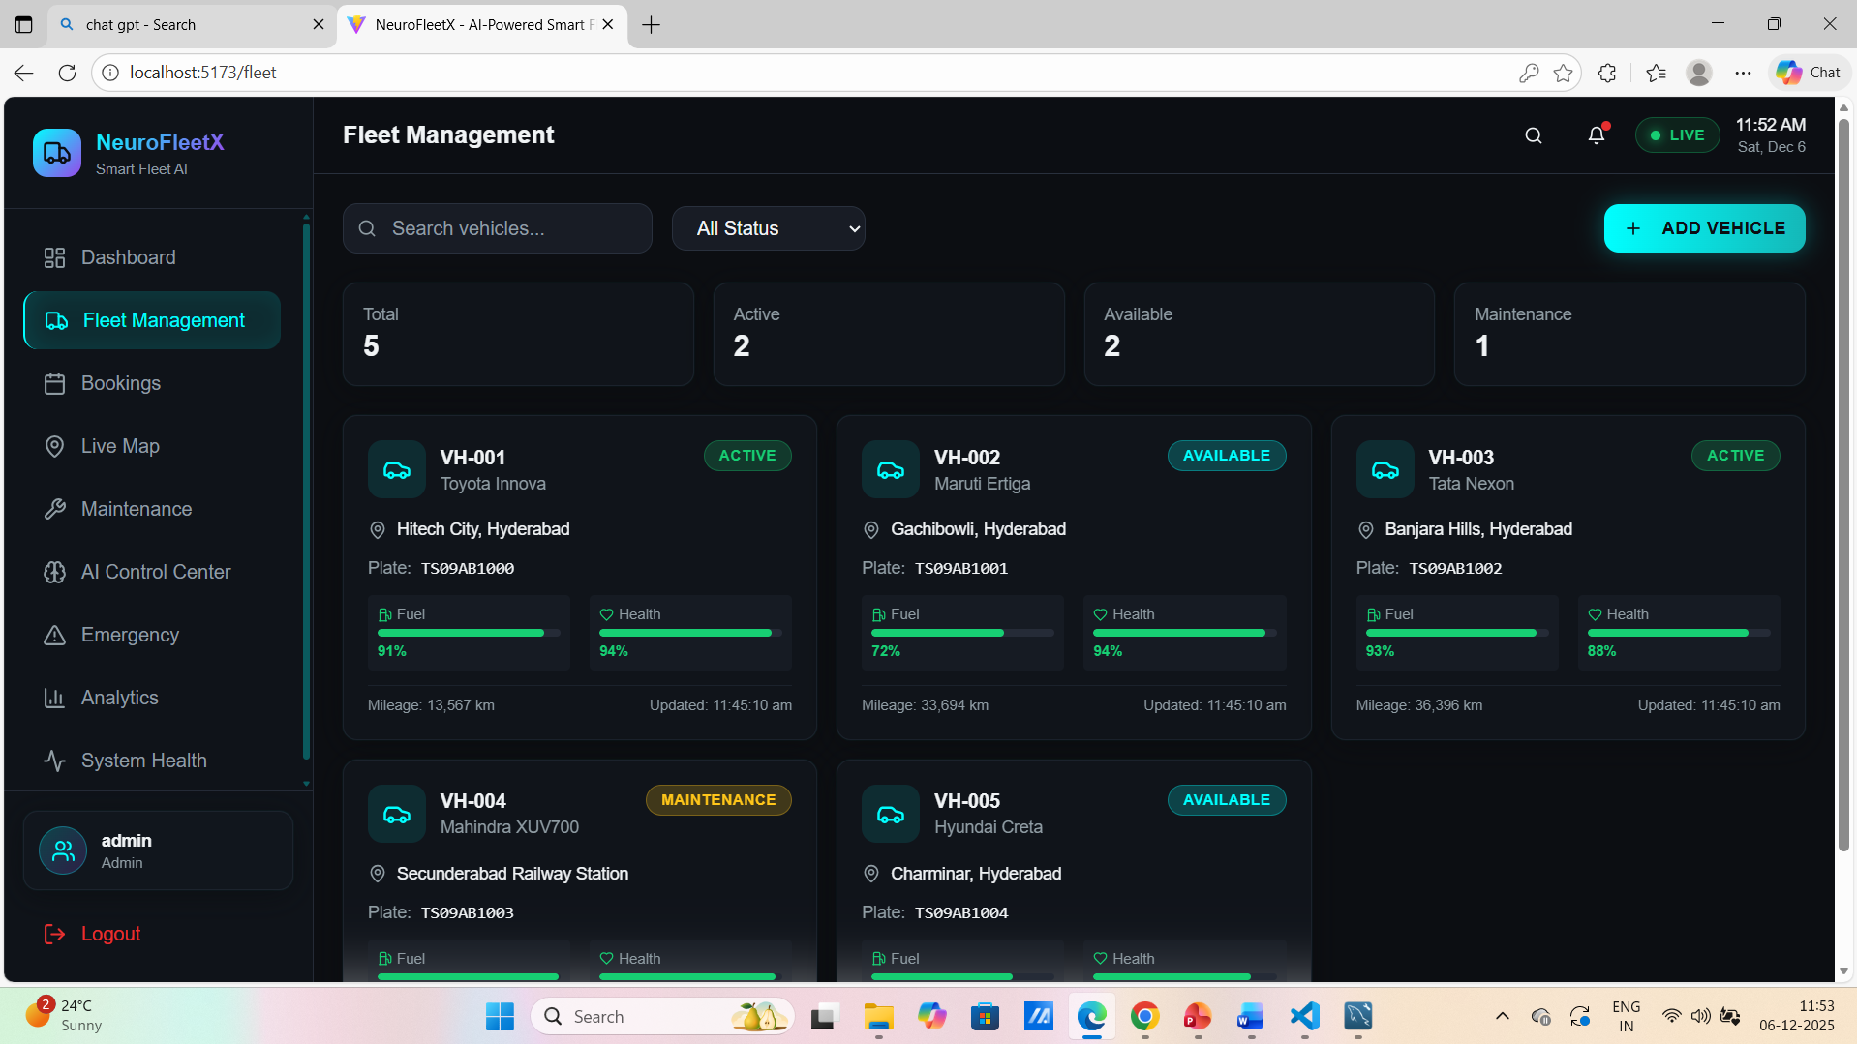

7. Challenges Faced
What Made the Work Difficult
- I had to learn new technologies like Spring Boot and React very quickly while building real features.
- Working with old, existing code was tough because it wasn't well documented.
- Sometimes my code worked in testing, but failed during important demos with connection errors or missing logs.
- Making real-time tracking and AI features work smoothly was challenging.

Working with Others and Time Pressure
- I felt constant pressure to finish tasks quickly while trying to understand complicated old code.
- As a new intern, I was sometimes shy to ask questions, worried I'd bother busy senior developers.
- Working from home made it harder to get quick answers, leading to delays.
- At times I felt alone figuring things out, which slowed me down.
How I Solved These Problems
- I set aside time every day specifically for learning and practice.
- I created a separate testing space to try things without breaking the main project.
- I started scheduling regular short meetings with my mentor and wrote my questions down first.
- When things went wrong during presentations, my team gave me extra time and helped me fix issues live, which taught me a lot.
- These experiences actually helped me learn faster about coding, systems, and teamwork.

8. Learnings & Skills Acquired
Technology Stack
Component | Technology
Backend | Spring Boot 3.5.7, Java 17
Frontend | React 18, TypeScript, Vite, Tailwind CSS
Database | MySQL 8.0+
Security | Spring Security, JWT (JJWT 0.11.5), BCrypt Password Encoding
Build Tools | Maven (Backend), Bun/NPM (Frontend)

9. Testimonials from team
I worked on a real project that turned my book knowledge into practical skills. Making the live map tracker work taught me how systems connect in real life. Fixing bugs made me much better at solving problems. I learned how to work in a team and write clear code. This experience is now the best example of what I can do as I start my career.

10. Conclusion
This internship with the NeuroFleetX project was a major milestone for my career. Working on a real-world application showed me exactly how the frontend, backend, and database connect and work together. I learned how to build features that update in real-time, which is a crucial skill for modern software.
The experience gave me a clear learning path, from planning and coding to testing and final documentation. It covered the complete software development lifecycle. This hands-on project has prepared me for a professional tech role and strongly aligns with my goal of becoming a full-stack developer.

11. Acknowledgements
Dear Senthil sir, I am deeply grateful to my mentor for their invaluable guidance and support throughout this internship. My sincere thanks to Infosys Springboard for providing this impactful learning opportunity. I also appreciate the entire project team for their collaboration and shared knowledge. This hands-on experience with NeuroFleetX has been foundational for my career in full-stack development. Thank you all for contributing to my professional journey.

